Phonics and Key Words

Key Words

Practise reading these key words:

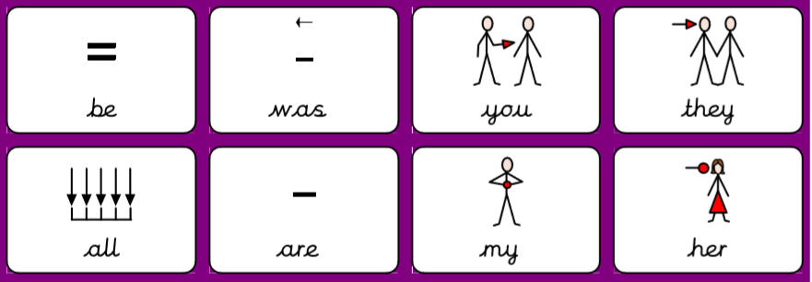
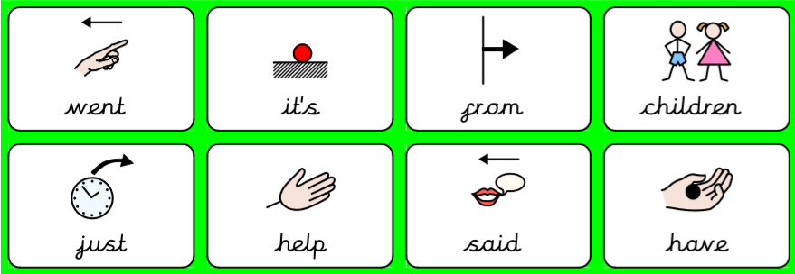

Practise writing these key words. The first two you can look to make sure you are spelling it right. Next, give it a go without looking. Lastly, check is you spelled it right!

Key word | Practise 1  (copy into space) | Practise 2  (copy again) | Practise 3  (fold and hide) | Can spell word  (check and correct)
be
was
you
they
not

Key word | Practise 1  (copy into space) | Practise 2  (copy again) | Practise 3  (fold and hide) | Can spell word  (check and correct)
all
are
my
her
went

Key word | Practise 1  (copy into space) | Practise 2  (copy again) | Practise 3  (fold and hide) | Can spell word  (check and correct)
it’s
from
children
just
help
said
have

Phonics:

Practise reading these entences with set 1 – 7 letters plus the four consonant digraphs and some tricky words. Circle ch sh th ng.

The van will chug up the long hill.
Sasha had a quick chat with Cath and me.
A moth can be fat, but its wings are thin.
The ship hit the rocks with a thud.
Lots of shops sell chicken as well as fish and chips.
Josh had a shock as he got a bash on the chin.

Read and write the following words. First segment the words e.g. cat – c – a – t. Then, try and read the words without segmenting them!

Focus GPCs = ‘ai ee igh oa’ – Vowel digraphs

ai | ee | igh | oa
wait | see | high | coat
Gail | feel | sigh | load
hail | weep | light | goat
pain | feet | might | loaf
aim | jeep | night | road
sail | seem | right | soap
main | meet | sight | oak
tail | week | fight | toad
rain | deep | tight | foal
bait | keep | tonight | boatman

Give it a go reading the following sentences with vowel digraphs.

The ship will sail.
I am in the rain.
My leg is in pain.
You can see a man.
It is wet all week.
Keep it in the box.

That is right.
I might go to bed.
They had a fight.
We can go on the boat.
The goat is big.
The tree is an oak tree.

Which sentence do you think goes with which picture?

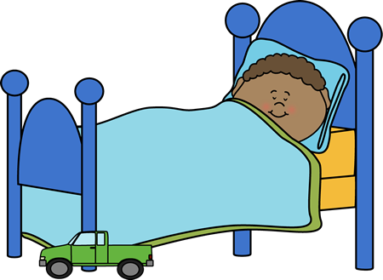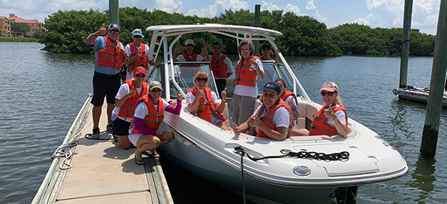

Handwriting:

Keep practising your handwriting – remember to write on the line! You can practise on any paper! If your paper does not have line – draw some!
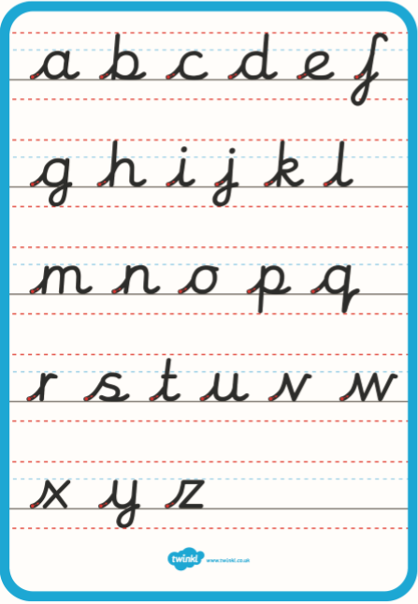

Practise your handwriting with the following words:

pain
feet
might
loaf

Everyday English:

Look at the following picture. What can you see? What are they doing? See if you can get someone to read you the questions.

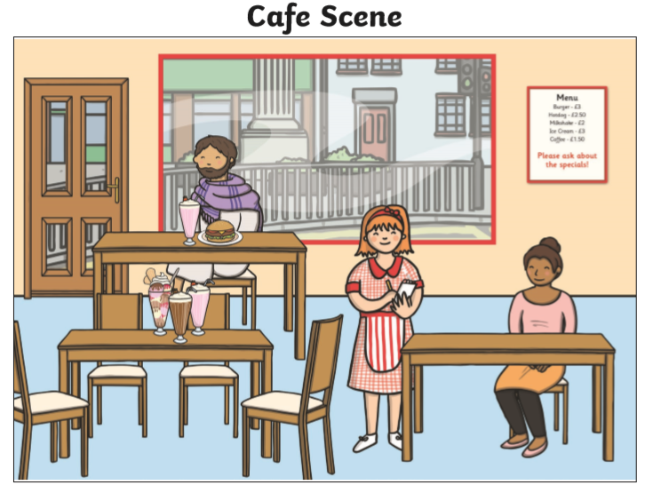

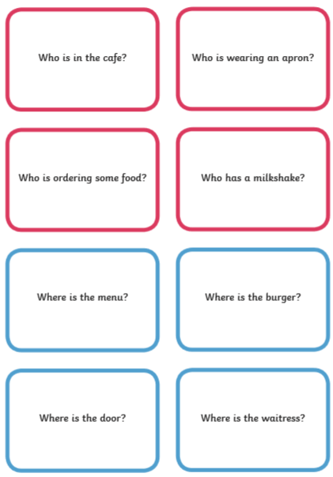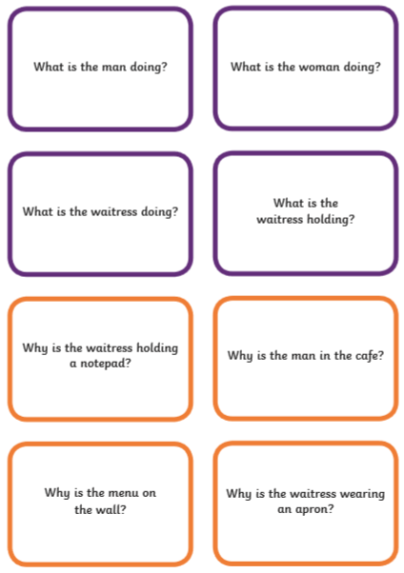

Try and use the following words:

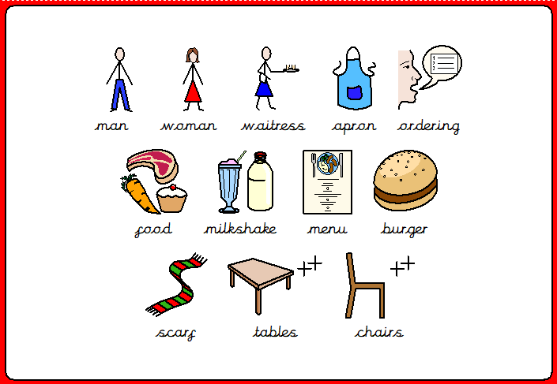

Verb labelling. Look at the words and label the picture.
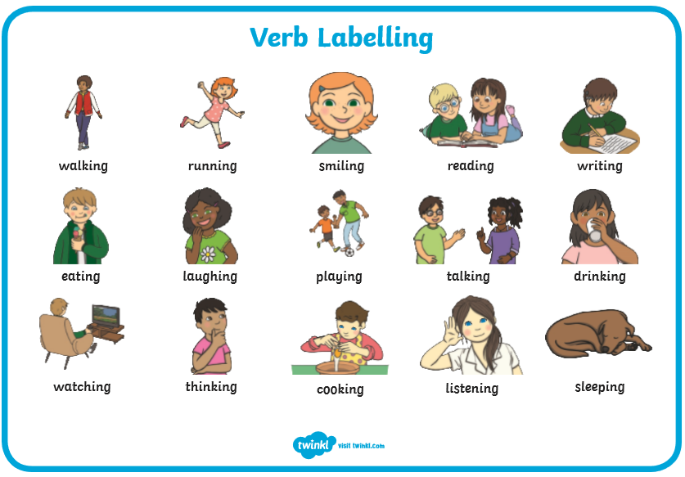
. 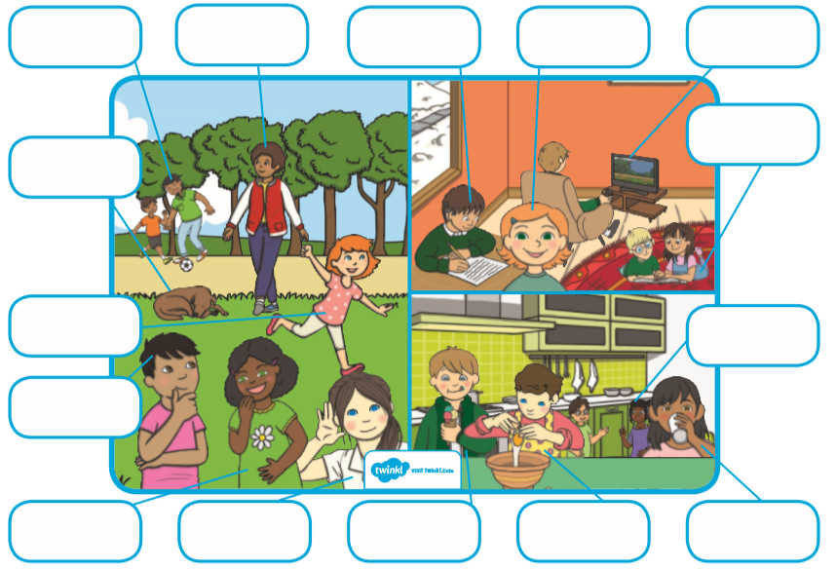

Talk!

Discussion of the week!
Look at the following question and discuss it with someone. Tell them WHY!
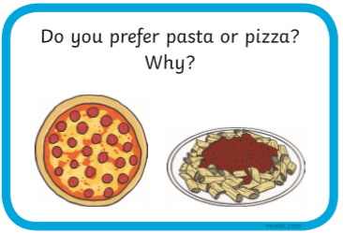

Useful websites:

Have a look at the following websites

- https://www.bbc.co.uk/cbeebies/shows/alphablocks - great phonics videos!
- https://www.bbc.co.uk/cbeebies/shows/numberblocks - great number videos!
- https://www.phonicsplay.co.uk/# - free to sign up!
- https://www.youtube.com/channel/UCP_FbjYUP_UtldV2K_-niWw - start from reception and work your way through!

I hope you enjoy the work and have a great week!

